ANCESTRAL PUEBLOAN PLASTER AND PAINT: PROCEDURE
Mesa Verde National Park has some of the best preserved plaster examples created by the Ancestral Puebloan people between 1200 and 1300 A.D. The park’s alcove sites contain well-preserved rooms like this one found at Cliff Palace.
Color Preparation: Observe, Question, Hypothesize
- List your observations of the plasters and paint below:

- Look at your list of observations. Think of questions based on your observations:

- Hypothesis: Use an “if … then … because” statement to explain which soil will match the desired color and try to explain why it matches. (Hint: science isn’t just explaining that something works, you have to be able to say why it works.)

If…____________________________________________________

then…__________________________________________________

because…_______________________________________________.
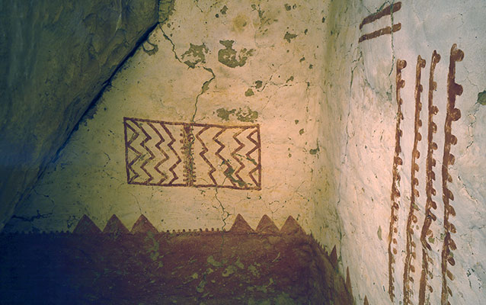

Note: Steps 4 through 12 are all considered the “test” or experimentation step of the scientific method used in this activity.
- Test hypothesis: Place one of the crushed soils into a mortar. Use a pestle to grind the soil into a fine powder.
- Place the prepared soil powder into a disposable cup. Write your observations:
- What are the colors and textures of the soil?

- Is the soil mostly sand, silt or clay? (Remember, sand is really gritty, silt is a little gritty, and clay is sticky or slick, depending on the moisture content).

- What else do you notice?

- Set prepared soil to the side for later use
Mixing Color
- Get a cup with clay.
- Add water to “thin” the mixture until it is like wet paint. Note: Clay particles enable plaster to the have the ability to form very thin layers.
- Mix in soil color and add water as needed, to maintain consistency created in step 8. (i.e. plaster should not be too wet, but not too dry).
Plaster Artwork
- With masking tape, carefully tape paper edges to clip board. This is done so that the artwork will dry flat and be easier to paint.
- Lightly draw on paper with a pencil, until satisfied with a plaster composition.
- Brainstorm: What do you think the Ancestral Puebloans used to plan their designs since they didn’t have paper, pencils, or clipboards?

- Experiment with depth of color and mixing in different soils (you can borrow colors from neighbors or make a new color). Use different sizes and kinds of paintbrushes, sponges, and rags.

- When finished, review your hypothesis from step three. Revise and re-write your hypothesis below:

If…____________________________________________________

then…__________________________________________________

because…_______________________________________________.

- Can you form any other conclusions based on your artwork experiment?

